
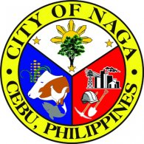
Republic of the Philippines
Province of @prov
@mun
Rural Health Unit
MEDICAL CERTIFICATE
TO WHOM IT MAY CONCERN:
This is to certify that MR./MRS./MS. @applicant, @age years old, Male/Female, married/single and resident of Barangay @brgy, @mun, @prov was seen and examined by the undersigned on @dexam, 2018, and evaluated with Essentially Normal Physical Findings at the time of Examination.
Issued this @day day of @month @year, at Rural Health Unit of @mun, @prov.
 |  |  | @head
 |  |  | Municipal Health Officer
Amt Fee: | @amount
OR No.: | @orno
Date: | @datepaid
@mun, @prov, Philippines

